

A PROJECT REPORT ON

“AI POWERED INTERACTIVE LEARNING ASSISTANT FOR CLASSROOMS”

Submitted to

INTEL Unnati Industrial Training Program 2025

Submitted By

Students of Department : ELECTRONICS AND COMMUNICATION EGINEERING.

STUDENT NAME : SHREEGOWRI .S
STUDENT NAME : SAVITA. C
STUDENT NAME : SANTOSH S

Guide name:
PROF SANGEETA
ABSTRACT :

This project proposes the development of an AI-powered interactive learning assistant for classrooms, designed to enhance student engagement and academic outcomes. Leveraging natural language processing (NLP), machine learning, and computer vision, the system provides real-time support and feedback to students through multi-modal interactions, including text, voice, and visuals. Key features include personalized learning, automated grading, real-time feedback, and interactive learning experiences. The system aims to reduce teacher workload, improve student accessibility, and provide valuable insights for educators. Future developments include integrating generative AI, emotionally aware learning, and immersive AR/VR experiences to further revolutionize the classroom experience.
INTRODUCTION:

In the evolving landscape of education, artificial intelligence (AI) has emerged as a trans-formative force with the potential to reshape how knowledge is delivered and consumed. Traditional classroom environments often struggle to cater to the diverse learning needs and paces of individual students. To address these challenges, the integration of AI-powered tools offers promising solutions that foster personalized, interactive, and engaging learning experiences.
This report explores the development of an AI-Powered Interactive Learning Assistant designed specifically for classroom environments. The assistant leverages multi-modal AI, enabling it to understand and respond to queries using a combination of text, voice, and visual inputs. By incorporating advanced natural language processing (NLP), speech recognition, and computer vision techniques, the assistant aims to create a dynamic learning atmosphere that adapts to student needs in real time.
The core objective of this project is to enhance student engagement through responsive, context-aware interactions. Whether answering subject-specific questions, interpreting images or diagrams, or facilitating voice-based discussions, the assistant is intended to act as a versatile support system for both educators and learners.
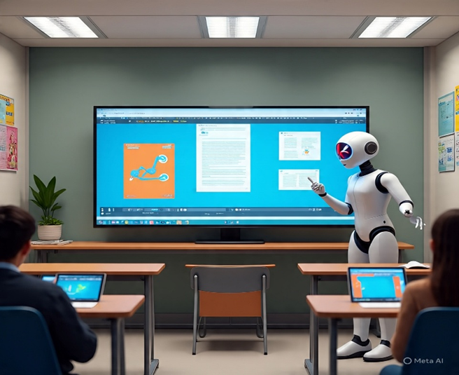
To build this system, a solid understanding of NLP and multi-modal AI is required, alongside practical experience with technologies such as Hugging Face Transformers, Open-CV, and speech-to-text frameworks. The integration of these tools forms the foundation for a robust, intelligent assistant capable of operating in diverse educational scenarios.

DATASET DESCRIMINATION:
To effectively build and train a multi-modal AI-powered interactive learning assistant, diverse and representative datasets across multiple domains—text, speech, and visuals—are essential. Each modality contributes to a different aspect of the assistant’s capabilities, and their integration ensures the system can operate in dynamic classroom settings. The following classification outlines the key datasets needed and their respective roles in the development process:

1. Textual Data

Text data is central to enabling the assistant’s natural language understanding and generation capabilities. This includes question answering, content summarization, dialogue generation, and subject-specific assistance.
Educational QA Datasets:
Squad (Stanford Question Answering Dateset) – for comprehension-based QA.
TQA (Textbook Question Answering) – aligned with school textbook material.
Wiki-QA, Natural Questions – for open-domain factual questions.
Dialogue Datasets:
Ed Net, Open Subtitles, or Daily-dialog – for conversational modeling.
Subject-Specific Content:
Curated datasets for Math, Science, History, etc., from Khan Academy, CK-12, or OpenStax.

2. Speech Data

Speech data is critical for enabling voice-based interaction between students and the assistant. The system must accurately convert spoken input to text (speech-to-text) and potentially read out responses (text-to-speech).
Speech-to-Text (ASR) Datasets:
LibriSpeech – general-purpose English speech dataset.
Mozilla Common Voice – diverse accents and speaker demographics.
TED-LIUM – lecture-style speech data, useful for classroom emulation.
Text-to-Speech (TTS) Datasets:
LJ Speech, VCTK Corpus – for training expressive, clear speech synthesis models.

3. Visual Data

Visual input allows the assistant to interpret images, diagrams, handwritten notes, or visual questions (e.g., charts, geometry problems).
Image Understanding:
Visual Question Answering (VQA v2) – combines images with related questions and answers.
CLEVR – tests reasoning over synthetic scenes.
AI2D – scientific diagrams with labeled parts and functions.
Handwriting and OCR Datasets:
IAM Handwriting Database, MNIST Extended – for handwritten text recognition.
DocVQA – for understanding structured document-based questions.

4. Multimodal Integration Datasets

These datasets include multiple types of data (e.g., text and image) and are crucial for developing models that integrate and reason across modalities.
TVQA (Text+Video QA) – useful for combining spoken/video lectures with question answering.
TQA (Textbook QA) – includes diagrams, text, and questions.
Science QA – multi-modal QA benchmark for science education (includes diagrams, OCR, and text).

METHODOLOGY:
1. Requirements Gathering: Identify the needs and requirements of students, teachers, and educators through surveys, interviews, and literature reviews.
2. System Design: Design the architecture of the AI-powered interactive learning assistant, including the NLP, machine learning, and computer vision components.
3. Development: Develop the system using Python programming language and libraries such as Hugging Face Transformers and Open-CV.
4. Testing and Evaluation: Test the system with a pilot group of students and teachers, and evaluate its effectiveness in improving student engagement and academic outcomes.
5. Refinement and Deployment: Refine the system based on feedback and deploy it in classrooms for wider use.
6. Continuous Improvement: Continuously collect feedback and improve the system to ensure it meets the evolving needs of students and teachers.

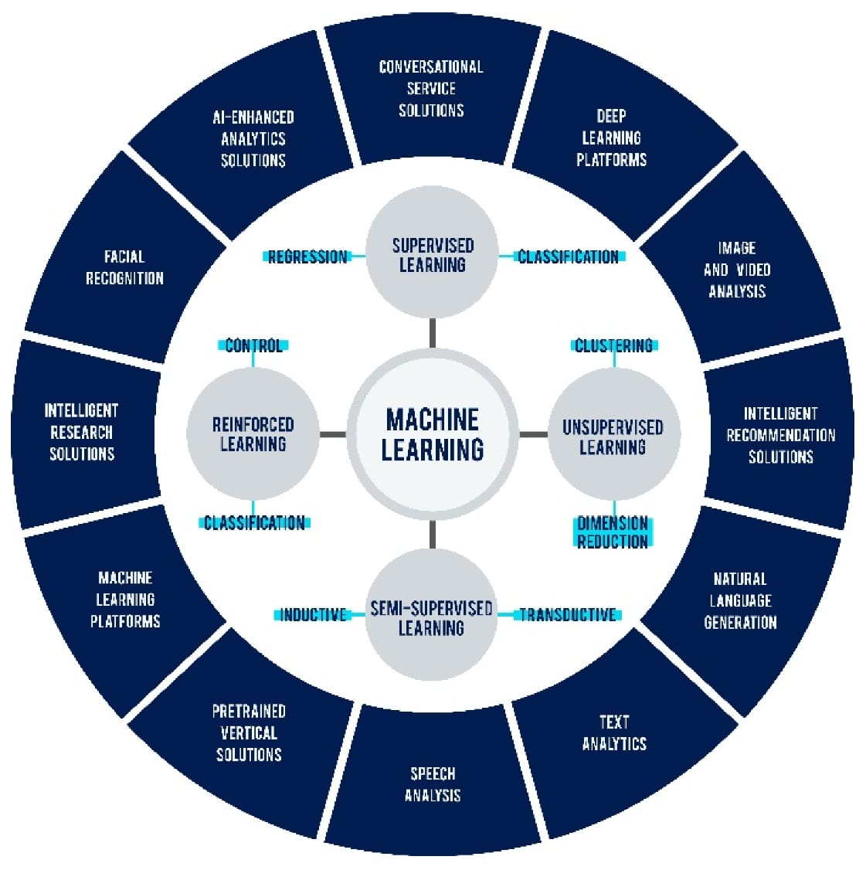

TOOLS AND TECHNOLOGYS:
1. Python Programming Language: For developing the system.
2. Hugging Face Transformers: For NLP tasks.
3. Open-CV: For computer vision tasks.
4. Machine Learning Frameworks: For building and training machine learning models.

PROJECT OBJECTIVE:
The primary objective of this project is to build a multi-modal AI assistant specifically tailored for classrooms. This assistant aims to dynamically answer student queries not just through text, but also via voice and visual inputs. Crucially, the system will focus on improving student engagement by delivering personalized responses that cater to individual learning styles and needs. By integrating NLP, speech-to-text, and computer vision techniques, the project seeks to create a truly interactive and responsive learning companion that can augment the teaching process and empower students to explore knowledge more independently and effectively.

KEY TECHNOLOGIES AND FRAMEWORK:

The development of a multi-modal AI-powered learning assistant relies heavily on several
mature and emerging AI technologies:
* Natural Language Processing (NLP): This field enables machines to understand, interpret,
and generate human language. Core NLP tasks relevant to this project include question
answering, sentiment analysis, text summarization, and named entity recognition. Hugging
Face Transformers, for instance, provides pre-trained models (like BERT, GPT, T5) that are
highly effective for these tasks, offering state-of-the-art performance in language
understanding and generation.
* Speech-to-Text (STT) and Text-to-Speech (TTS): STT technology converts spoken words
into written text, allowing the AI to understand voice commands and queries. Conversely,
TTS converts text into synthesized speech, enabling the AI to respond verbally. Advanced
deep learning models have significantly improved the accuracy and naturalness of these
conversions, making voice interaction seamless.
* Computer Vision (CV): This domain equips machines with the ability to "see" and interpret
visual information from images or videos. In a classroom setting, computer vision could be
used for object recognition (e.g., identifying items on a diagram), optical character
recognition (OCR) for text in images, or even analyzing student gestures or expressions
(with appropriate ethical considerations). Open-CV is a widely used library providing a
comprehensive suite of functions for real-time computer vision tasks.

SYSTEM ARCHITECTURE OVERVIEW:

The proposed assistant will operate on a modular architecture, allowing for independent
development and flexible integration of various AI components. At a high level, the system
can be visualized as:
* Input Layer: Receives diverse student inputs (text, voice, image/video).
* Modality Processing Layer: Dedicated modules for each modality (NLP for text,
Speech-to-Text for audio, Computer Vision for visuals) convert raw inputs into structured,
machine-understandable formats.
* Multi-modal Fusion Layer: Combines processed data from different modalities to create a
holistic understanding of the student's query and context. This layer is crucial for
disambiguation and comprehensive query interpretation.
* Knowledge Base/Reasoning Engine: Accesses a curated educational knowledge base and
employs logical reasoning to formulate appropriate responses. This may include pre-loaded
curriculum content, factual databases, and dynamic search capabilities.
* Personalization Engine: Analyzes student profiles, historical interactions, learning
progress, and inferred learning styles to tailor responses, difficulty levels, and engagement
strategies.
* Response Generation Layer: Formulates the assistant's output, deciding on the most
effective modality (text, voice, visuals, or a combination) for the answer.
* Output Layer: Delivers the generated response back to the student (Text-to-Speech for
audio, visual display for text and images/videos).

CHALLENGES AND CONSIDERATIONS:
While the potential benefits are immense, the deployment of an AI-powered learning
assistant comes with significant challenges that must be carefully addressed:
Ethical Implications and Bias
* Algorithmic Bias: AI models can inherit and amplify biases present in their training data.
This could lead to unfair or inequitable responses for students from certain backgrounds or
demographics. Rigorous testing and bias mitigation strategies are crucial.
* Fairness and Equity: Ensuring the assistant serves all students equally, regardless of their
socioeconomic status, disability, or access to technology outside the classroom.
* Transparency: Making the AI's decision-making process as transparent as possible to
build trust with students, teachers, and parents.
+ Data Privacy and Security
* Sensitive Student Data: The assistant will collect vast amounts of sensitive student data
(learning patterns, queries, voice recordings, visual interactions). Strict adherence to data
protection regulations (e.g., GDPR, COPPA) is paramount.
* Security Breaches: Protecting this data from cyber threats and unauthorized access.
Robust encryption, secure storage, and access controls are essential.
* Consent: Obtaining informed consent from students and parents regarding data collection
and usage.
+ Integration with Existing Classroom Infrastructure
* Compatibility: Ensuring the assistant can integrate with existing learning management
systems (LMS), digital whiteboards, and other educational technology.

RESULT:

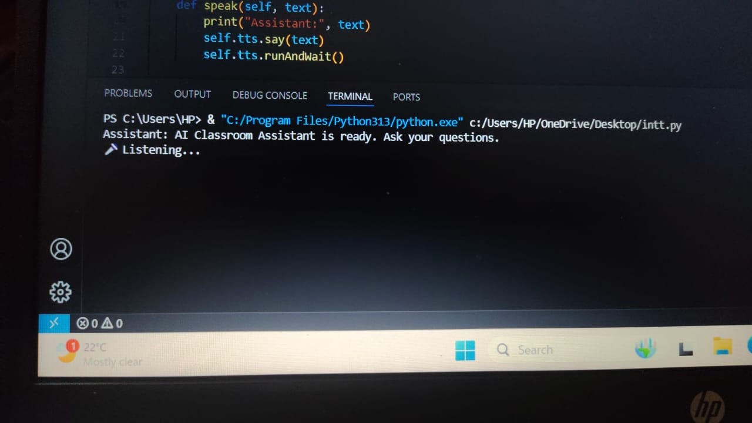

CODE:

import openai
import speech_recognition as sr
import pyttsx3
import webbrowser
import requests
import io
from PIL import Image

# ✅ Set your OpenAI API key
openai.api_key = "sk-...s-cA" # Replace with your OpenAI API key

class LearningAssistant:
def _init_(self):
self.recognizer = sr.Recognizer()
self.tts = pyttsx3.init()
self.tts.setProperty('rate', 150)

def speak(self, text):
print("Assistant:", text)
self.tts.say(text)
self.tts.runAndWait()

def listen(self):
with sr.Microphone() as source:
print("🎤 Listening...")
audio = self.recognizer.listen(source)
try:
query = self.recognizer.recognize_google(audio)
print("You said:", query)
return query
except sr.UnknownValueError:
self.speak("Sorry, I could not understand.")
return None
except sr.RequestError:
self.speak("Network error.")
return None

def get_answer(self, query):
response = openai.ChatCompletion.create(
model="gpt-4",
messages=[{"role": "user", "content": query}]
)
return response.choices[0].message.content

def generate_image(self, prompt):
response = openai.Image.create(prompt=prompt, n=1, size="512x512")
image_url = response['data'][0]['url']
img_data = requests.get(image_url).content
img = Image.open(io.BytesIO(img_data))
img.show()

def play_video(self, topic):
search_query = topic.replace(" ", "+")
url = f"https://www.youtube.com/results?search_query={search_query}"
self.speak("Opening YouTube...")
webbrowser.open(url)

def handle_query(self, query):
query = query.lower()
if "show image of" in query:
prompt = query.replace("show image of", "").strip()
self.speak(f"Generating image of {prompt}")
self.generate_image(prompt)

elif "play video" in query:
topic = query.replace("play video", "").strip()
self.play_video(topic)

else:
answer = self.get_answer(query)
self.speak(answer)

def run(self):
self.speak("AI Classroom Assistant is ready. Ask your questions.")
while True:
query = self.listen()
if query:
if "exit" in query.lower():
self.speak("Goodbye!")
break
self.handle_query(query)

# Run the assistant
if _name_ == "_main_":
assistant = LearningAssistant()
assistant.run()

CONCLUSION AND FUTURE SCOPE:
The AI-Powered Interactive Learning Assistant represents a trans-formative approach to classroom education by offering several key benefits. It provides personalized learning by adapting content and teaching methods to suit each student's pace, style, and needs. The tool promotes enhanced engagement through dynamic, multi-modal interactions, and delivers immediate feedback, helping reduce learning friction. With its accessibility features, it accommodates diverse learners through various input and output modes. Additionally, it serves as a teacher augmentation tool, freeing educators from routine tasks so they can focus on deeper instruction and individual mentoring.

This intelligent assistant holds significant potential to impact education positively. It can bridge learning gaps by proactively identifying and addressing student weaknesses, and it encourages self-directed learning, enabling students to explore topics independently. The system can help standardize the quality of education by offering consistent, high-quality explanations across different classrooms. Moreover, it supports data-driven pedagogy by generating insights into student learning behaviors, allowing educators to refine their teaching strategies.

Looking ahead, the scope for future enhancements is both vast and promising. One area involves developing deeper contextual understanding, allowing the assistant to anticipate student needs, recognize misconceptions, and guide them through complex problem-solving using advanced reasoning and cognitive modeling. It may also support proactive learning interventions, such as detecting disengagement and providing timely prompts or adjustments. Integrating emotional intelligence would enable the assistant to respond empathetically to student emotions like frustration or excitement, creating more supportive learning experiences. The assistant could also enable collaborative learning, acting as a moderator in group tasks or peer learning scenarios. Additional capabilities may include adaptive content generation, where learning materials are created on the fly based on student performance, and integration with VR/AR to offer immersive, hands-on learning experiences. Other potential developments include longitudinal student modeling, providing long-term, personalized academic support, and multilingual support, which would make education more globally inclusive and accessible.

SOLUTION FEATURES:
The AI-Powered Interactive Learning Assistant is designed to transform the traditional classroom into a dynamic, personalized, and inclusive learning environment. By integrating multi-modal AI technologies, the system offers a range of intelligent features that enhance student engagement and streamline the learning process for educators. Below are the core features of the proposed solution:
1. Multimodal Query Handling
Text Input: Students can type questions or prompts into the system.Voice Interaction: Supports real-time voice-based queries using speech-to-text and text-to-speech (TTS) technologies.Visual Input: Accepts images of diagrams, handwritten notes, or visual problems and extracts meaningful data using computer vision.
2. Natural Language Understanding and Response Generation
Utilizes advanced NLP models (e.g., Transformers) to understand the context of queries and provide accurate, subject-specific responses.Capable of dialogue-based learning, where students can ask follow-up questions for deeper clarification.
3. Personalized Learning Support
Tracks individual student performance and adapts content delivery accordingly.Provides tailored recommendations, explanations, and follow-ups based on the learner’s comprehension level and history.
4. Visual and Diagram Interpretation
Analyzes and explains educational visuals such as charts, graphs, maps, or science diagrams.Recognizes handwritten input using OCR and handwriting recognition models to answer questions related to math problems or notes.
5. Real-Time Voice Feedback
Uses text-to-speech (TTS) to read responses aloud, aiding auditory learners and students with reading difficulties.Can detect emotion or tone in student speech to adjust responses accordingly (e.g., encouragement when frustration is detected).
6. Interactive Content Delivery
Delivers quizzes, flashcards, and small assessments based on user interaction and classroom topics.Enables gamified learning experiences to boost motivation and participation.
7. Multilingual and Accessibility Support
Supports multiple languages to cater to diverse student populations.Offers accessibility features for students with visual, auditory, or learning impairments (e.g., screen reader compatibility, speech output).
8. Teacher Integration Tools
Allows teachers to monitor student engagement, performance, and frequently asked questions.Enables educators to customize the assistant’s behavior for specific lessons or topics.
9. Secure and Privacy-Aware Design
Ensures data privacy and security in accordance with educational data protection regulations (e.g., FERPA, GDPR).Student interaction data is anonymized and used solely for improving learning outcomes.
10. Offline and On-Device Capabilities (Optional)
Optionally supports offline mode for low-connectivity classrooms using on-device AI models.
Local processing can also enhance speed and reduce reliance on internet connectivity.

REFERENCES:
* Chen, L., Chen, P., & Lin, Z. (2020). Artificial intelligence in education: A review. IEEE
Access, 8, 75264–75278.
* Holmes, W., & Tuomi, I. (2022). State of the art and practice in AI in education. European
Journal of Education, 57(4), 542–570.
* Hwang, G. J., & Fu, Q. K. (2020). Roles of artificial intelligence in education: A systematic
review. International Journal of Distance Education Technologies (IJDET), 18(3), 41-59.
* OpenCV. (n.d.). Open-CV documentation. Retrieved from https://docs.opencv.org/
* Radford, A., et al. (2021). Learning transferable visual models from natural language
supervision. OpenAI.
* Vaswani, A., Shazeer, N., Parmar, N., Uszkoreit, J., Jones, L., Gomez, A. N., ... &
Polosukhin, I. (2017). Attention Is All You Need. Advances in Neural Information Processing
Systems, 30.
* Wolf, T., et al. (2019). HuggingFace's Transformers: State-of-the-art Natural Language
Processing. Proceedings of the 2019 Conference on Empirical Methods in Natural Language
Processing: System Demonstrations, 34-40.
* Zawacki-Richter, O., Marín, V. I., Bond, M., & Gouverneur, F. (2019). Systematic review of
research on artificialzp intelligence applications in higher education—where is the evidence
from and what has been studied?. International Journal of Educational Technology in Higher
Education, 16(1), 39

TEAM CONTRIBUTION:
While doing this project it involved a lot of research and browsing for the needs of the features and the material required for the process of encrypting and decryption of the file, this work was divided between the team members
- SANTOSH developed the for Code .
- SHREE GOWRI dealt with the process of Error debugging and modifying
- SAVITA made the reports and presentations with the necessary and required data.

